To install Linux on VM Workstation

# Version

Linux RHEL 6 Beta

VM Workstation 10

# Step by Step guide

1. Install VM by downloading the software
2. If VM is already installed, open VM Workstation software and go to HOME
3. Click on create a new VM
4. First only create a VM and then install the OS as direct install causes VM install to hang at VMWare tools throwing the error

/dev/hda does not exist

/dev/rdr does not exist

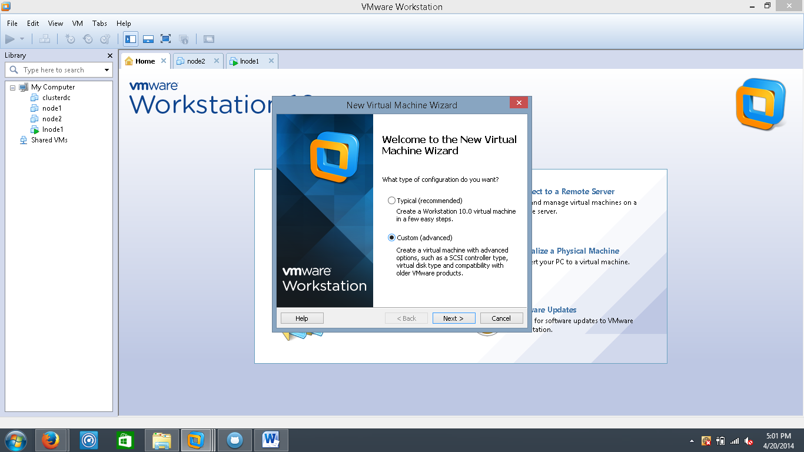

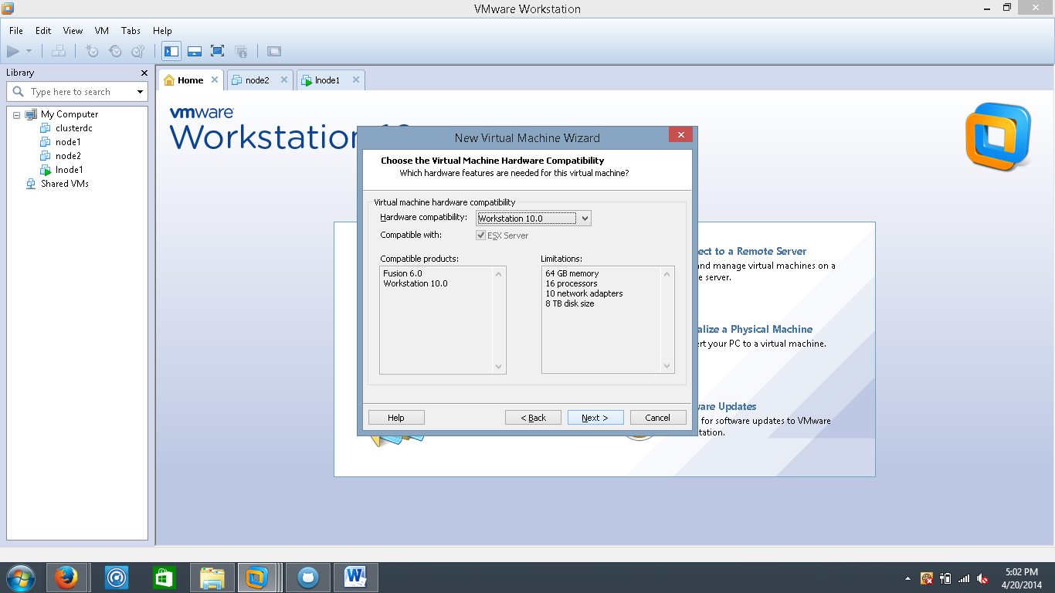

Choose Install OS later option

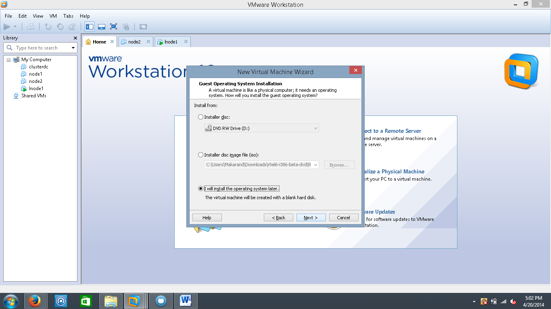

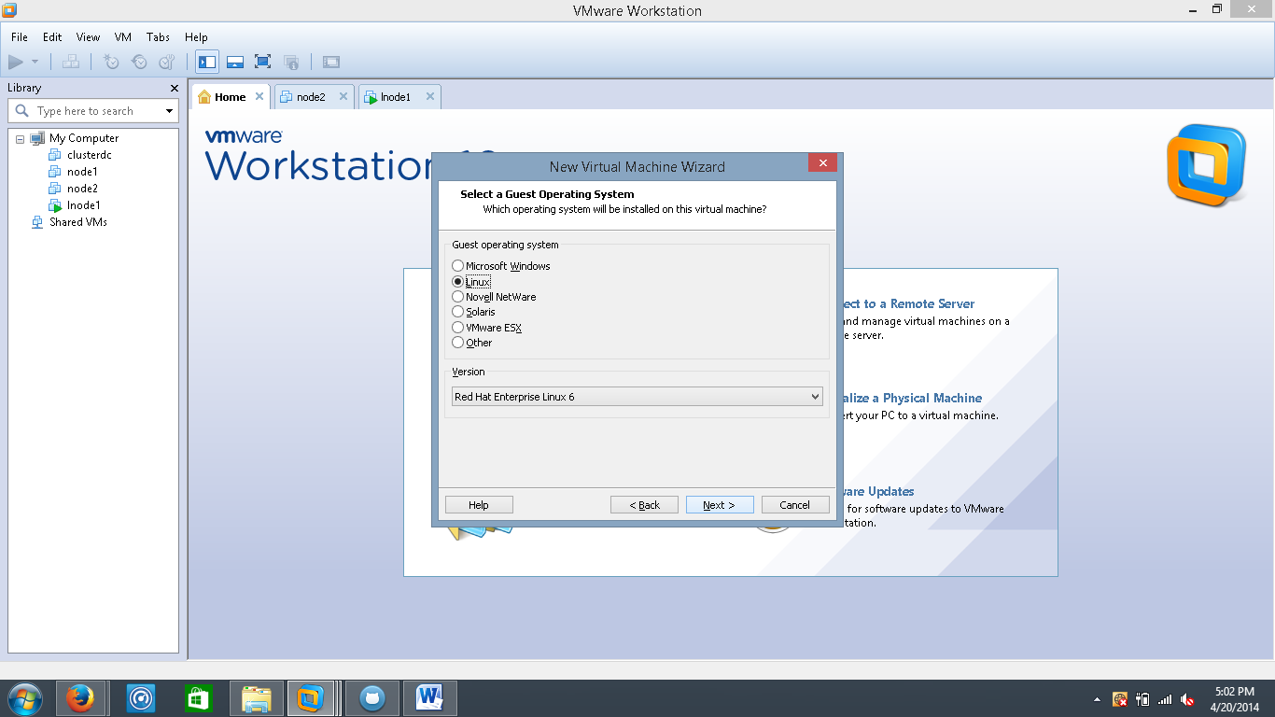

Select the name of the VM, vmdk file will be created in the said folder. So make sure to pick a folder with available space

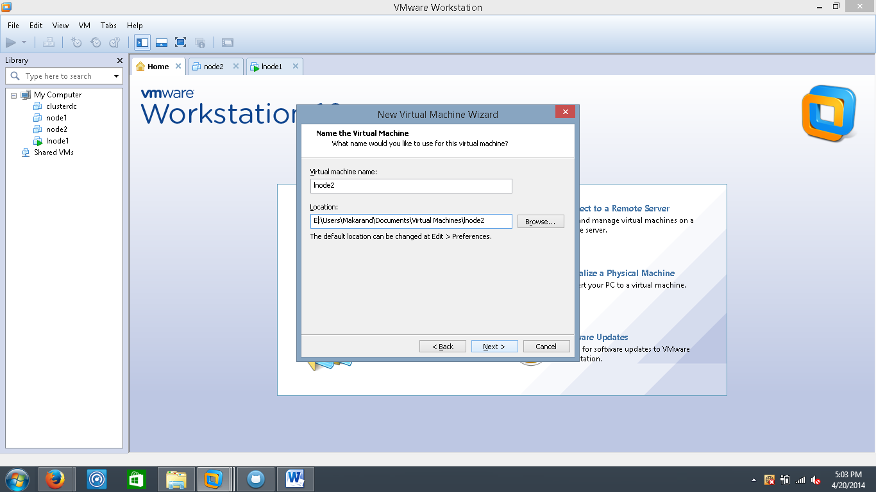

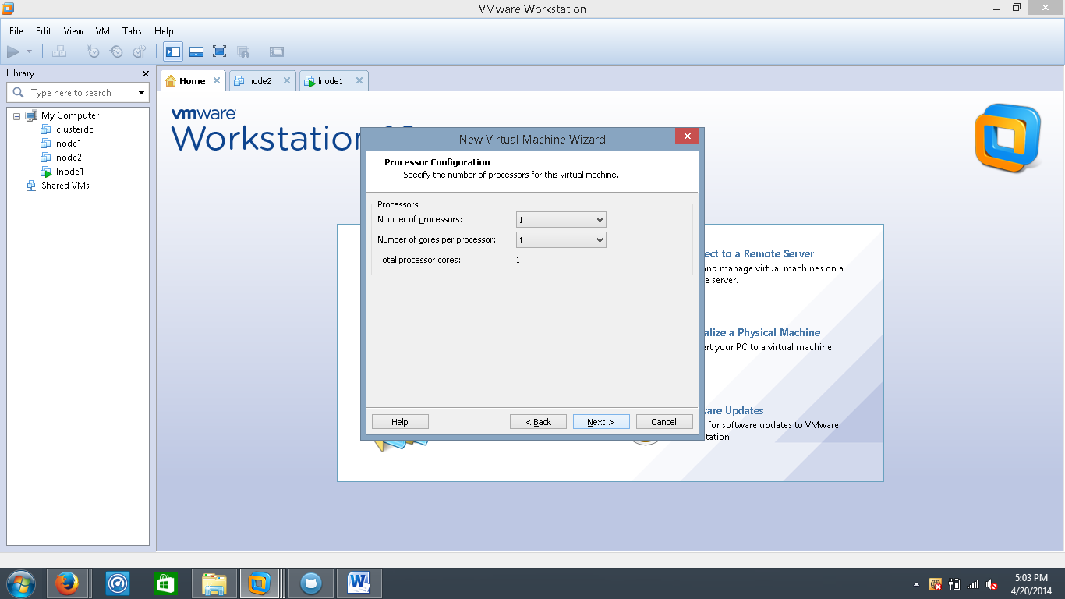

I reduce the default 2G memory to 512Mb

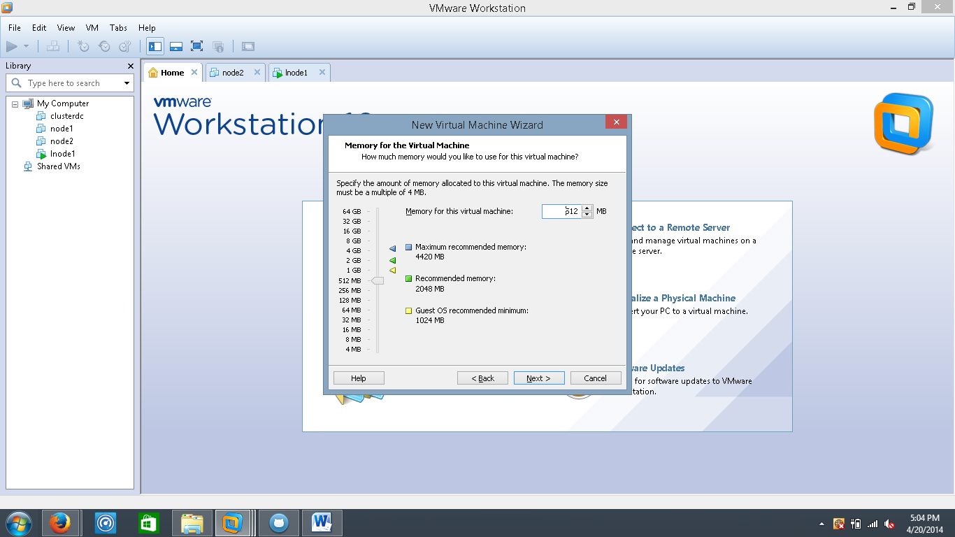

Use the bridged networking option

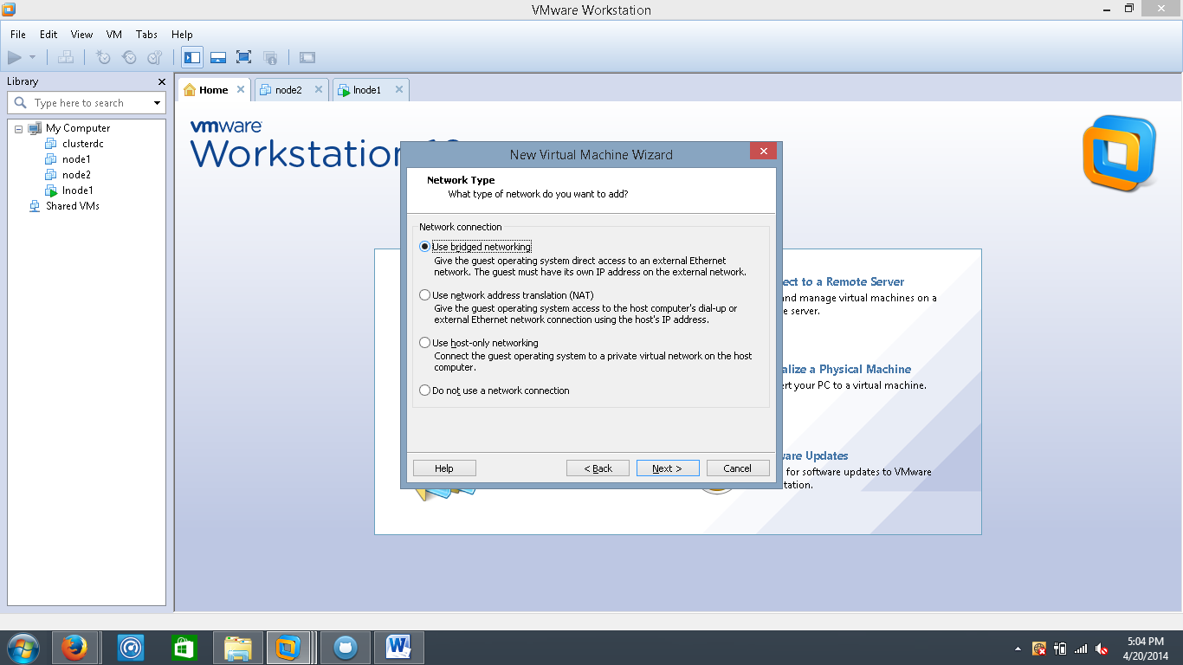

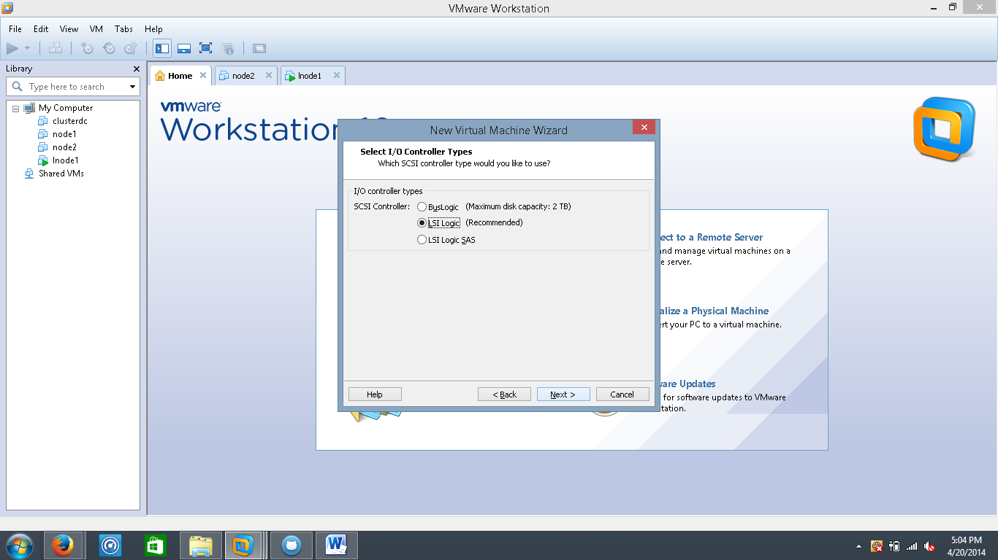

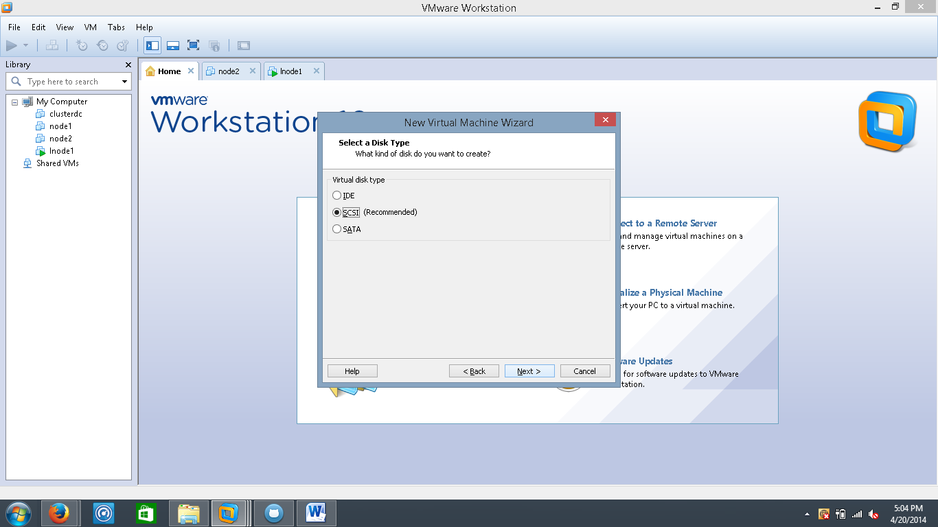

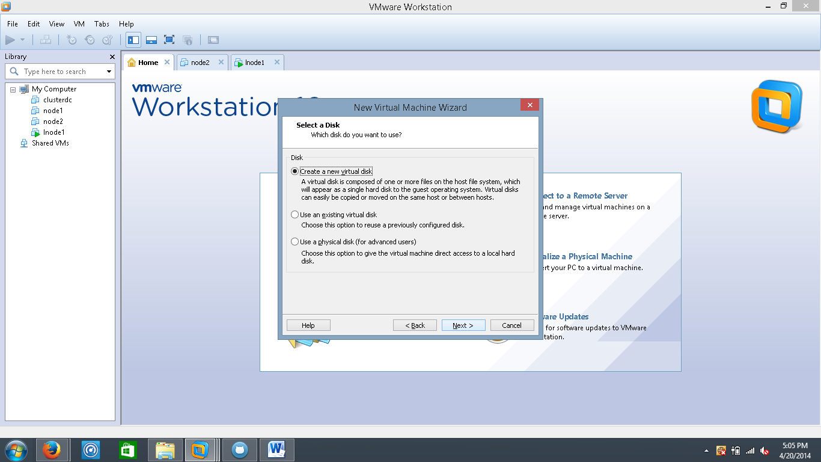

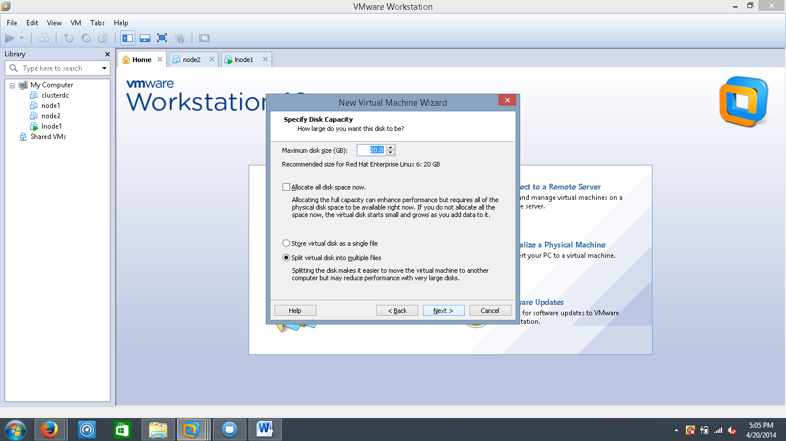

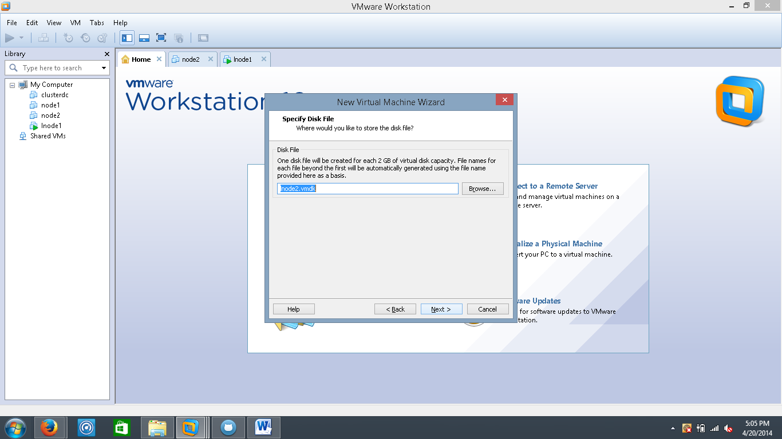

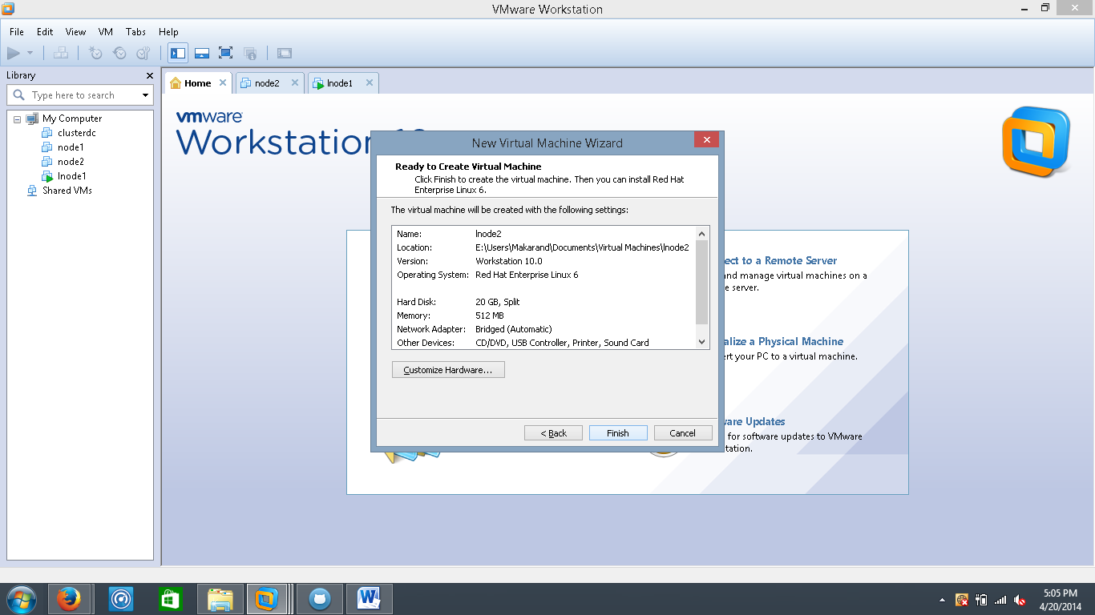

Once you click Finish it creates a VM for you, but it’s an empty VM without any OS installed in it. To install OS, right click the VM -> Settings -> CD/DVD (SATA) -> Use ISO File, browse to the ISO file

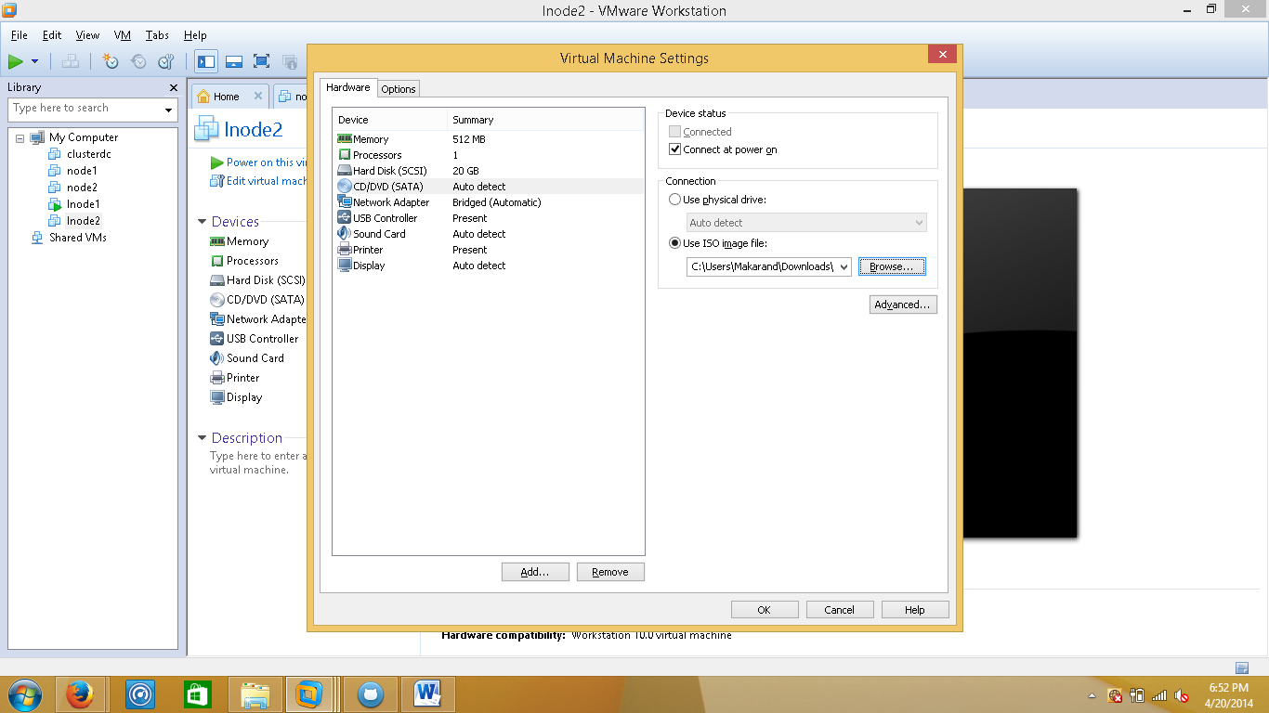

Right Click -> Power ON

